ACCIDENTS 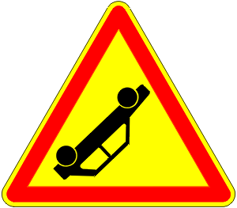

For each of the following tasks write about 150-230 words

- Look at the following picture and describe what has happened:
- - from the point of view of one of the involved drivers
- - from the point of view of one of a spectator/ witness
- - from the point of view of a policeman (write a report)

- Write a dialogue in which:
- – the two involved drivers argue heavily about the cause of the accident
- – a nosy neighbor who hasn’t seen what happened wants to know all the details

- You are an insurance agent (Versicherungsvertreter) who has by chance been at the scene of the accident. Try to convince the two drivers that they should sign a contract with your insurance company.

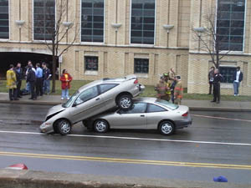

- Write about an accident in which you were involved.

